## In network tab of developer tools show the HTTP header details received:

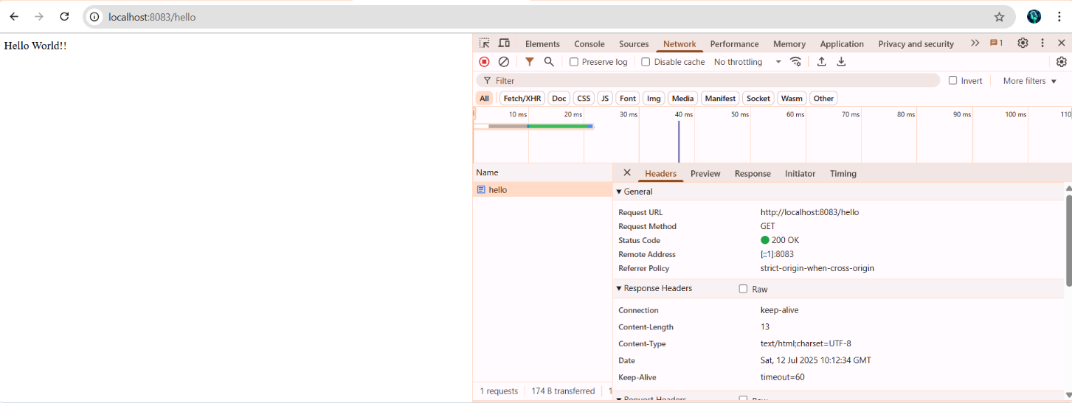

## In postman click on "Headers" tab to view the HTTP header details received:

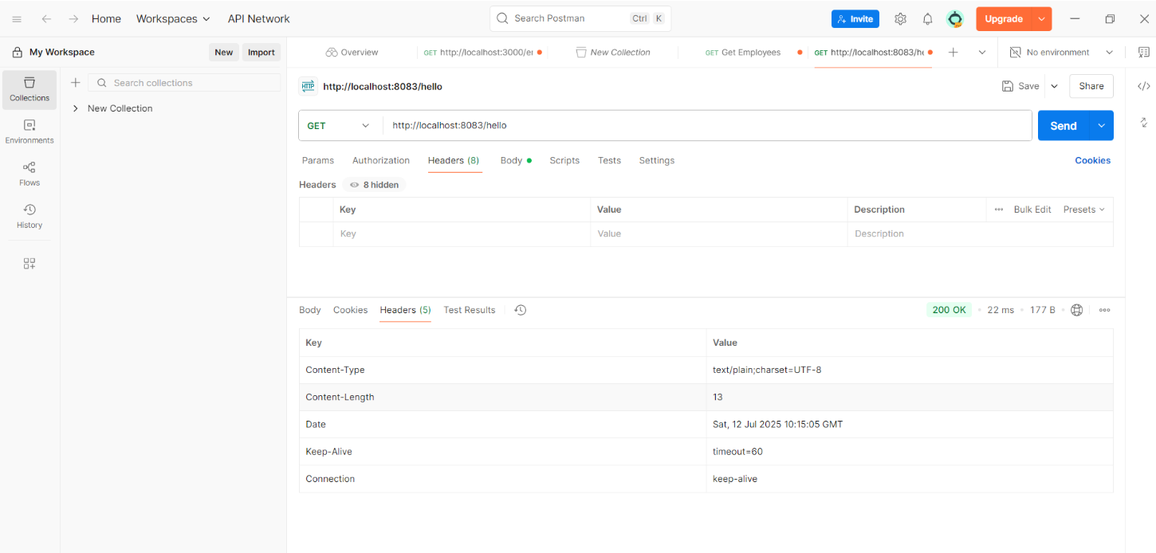

**What Are HTTP Headers?**

* **Request Headers**: Sent by the client (browser/Postman) to the server.
* **Response Headers**: Sent by the server back to the client.

Useful headers include:

* Content-Type: Describes the data type (e.g., application/json)
* Authorization: Contains credentials or tokens
* Date: Timestamp of response
* Cache-Control: Caching rules